Petal Pusher Flowers

If you would like to change the images on your website, you can upload a new image with the exact same name of the current image.

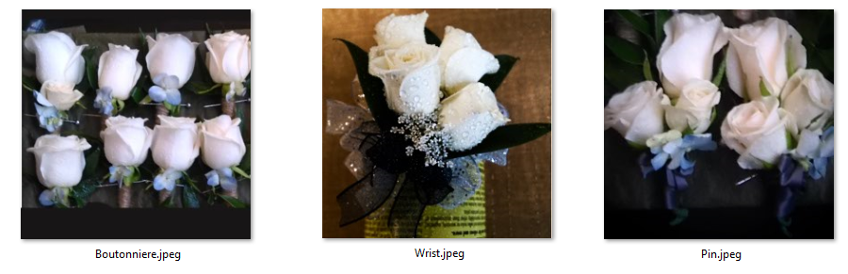

To upload files login to Bluehost and click on the File Manager in the files Category

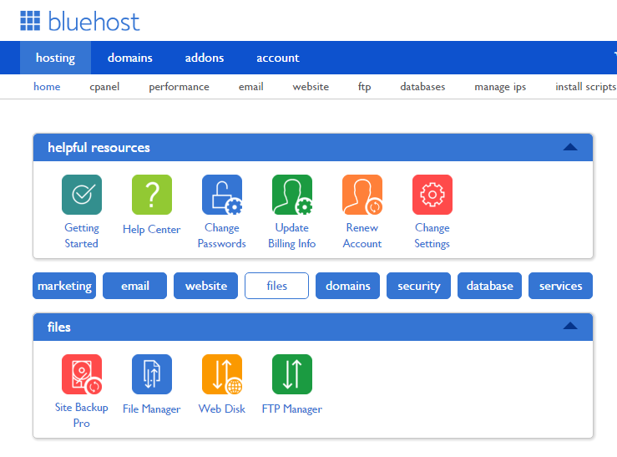

When you click on File Manager, it will let you see all the files for your website.

Click on public_html to get the files that have created your website

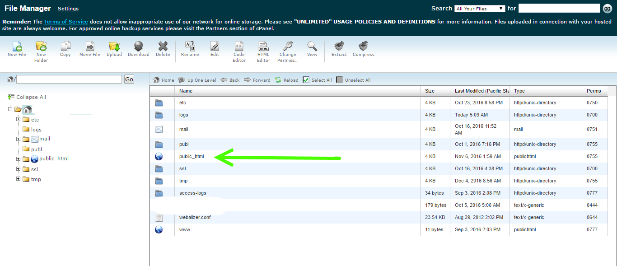

Next open the img folder, and then click Upload

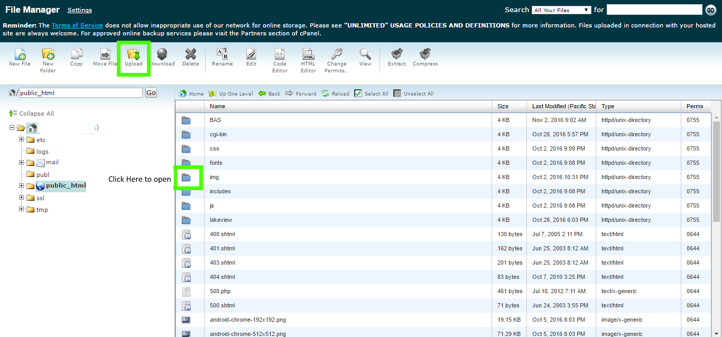

When you upload, you’ll click on Choose File to select the image and check the box **Overwrite existing files**.

Keep the Permissions as set by default.

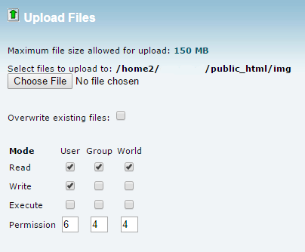

You can also use a program called Filezilla to copy files over from your computer

